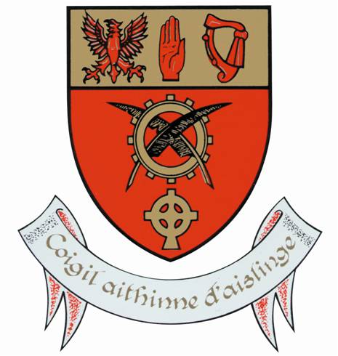

Moyne Community School
PERSON SPECIFICATION PRINCIPAL

Essential Criteria:

To qualify for appointment candidates must:
- Have Post-Primary Teaching Qualifications recognised by the Department of Education for the purpose of teaching in a second level school as defined by Department of Education.
- Have a minimum of five years’ whole time satisfactory teaching service or its equivalent.
- Be Route 2 registered with the Teaching Council at the time of application.

Core Competencies Required:

- Leading Learning & Teaching
Understands that high quality learning and teaching is the core business of a school and demonstrates the skills to act as the instructional leader promoting a culture of improvement and collaboration in this area.

- Leading School Development
Demonstrates the ability to establish and maintain a guiding vision for the school in line with the mission statement and communicates appropriately the goals and expectations of this vision to the school community.

- Developing Leadership Capacity
Empowers staff to carry out leadership roles, facilitates active student participation in school leadership while reflecting on the effectiveness and sustainability of their personal leadership and networking with other leaders.

- Communication
Demonstrates the capacity to clearly hear and articulate views, opinions and attitudes through effective, appropriate and empathic interaction with all stakeholders in a variety of situations and contexts.

- Managing the Organisation
Uses a range of resources, supports and processes to ensure the effective and efficient running of the school and develops and implements a system of professional responsibility and accountability.

- Self-Awareness and Self-Management
Is self-aware and has the capacity to self-manage and develop personally and professionally.

The successful candidate will:

- be a leader, committed to the highest standards of education provision, administration and governance
- have a passion for education
- have strong people management and organisation skills
- be a visionary and have experience in delivering projects through team work
- be community minded and conscious of the role the school plays in the local community

