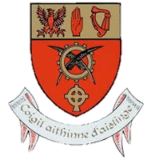
[Moyne Community school – application form tRANSITION yEAR]
Transition Year Application Form
2020/2021

Please complete this form and return It by email to mcampbell@moynecs.com
by Tuesday 2nd March 2021.
Please note: All questions must be answered.
Student’s Name
Class

Why do you want to do Transition Year?

What expectations do you have of Transition Year?

What qualities or talents can you bring to Transition Year?

What did you do to find out information about Transition Year?

How would your teachers describe you?

How would your friends describe you?

What aspects of your personality would you like to address in Transition Year?

How do you think that Transition Year could benefit you?

How do you plan to spend the free time that participating in TY will give you?

Student’s signature: |  |  | Date:
Parent/Guardian’s signature

