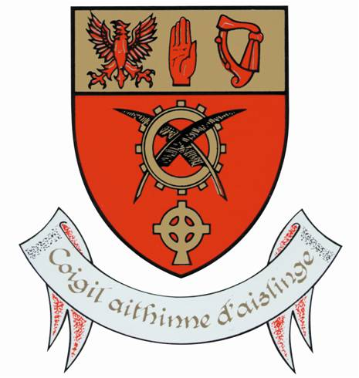
The Gemma McGee Memorial Bursary

Application Form 2020
Closing Date: Tuesday 8th December

Name:
Address:
Course (Level 6, 7, 8) being Studied:
College/ University:

Personal Statement:
Please submit a typed document divided into the following headings;
1. How would this bursary benefit you? - 200 words
2. How would you describe yourself? - 100 words
3. How would your teachers describe you? -200 words

Canvassing will disqualify.
RETURN BY POST TO:
Ms. Flanagan,
Chaplain,
Moyne Community School
Moyne
Co Longford
N39 T860

