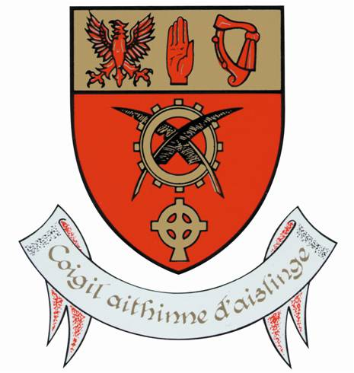
Moyne Community School
Moyne
Co Longford
N39 T860
049 433 5114
www.moynecs.ie

Registration of Interest to enrol in Moyne Community School for 2020/21
(PEASE COMPLETE IN BLACK PEN AND BLOCK CAPITAL LETTERS)
Pupil Name ______________________________________ Male ⃞ Female ⃞
Address _____________________________________________________________________
Date of Birth _________________________ PPS No _______________________

Mothers Name _____________________________________________________________________
Mothers address (if different from above)________________________________________________
Email address _____________________________________________________________________
Fathers Name _____________________________________________________________________
Fathers address (if different from above)_________________________________________________
Email address _____________________________________________________________________

Current Primary School ______________________________________________________________

Please note
- Submission of this form does not guarantee an offer of a place
- Once an offer of a place in 1st year 2020 has been issued a fully detailed application form will be issued and must be completed and return to secure the place
- Registration of interest form must be completed and returned to the school by 15th November 2019
- Please visit the school website http://moynecs.ie/school-planpolicies.html to view our school Admission Policy, Code of Behaviour and other school policies
- Personal Data collected about prospective students and their parents will be retained and used strictly in accordance with GDPR regulations

